**🧠 1. Count Word Frequency**

**Problem:**  
Given a sentence, count the frequency of each word using a dictionary.

**Example:**  
Input: "I love Python because I love coding"  
Output: {'I': 2, 'love': 2, 'Python': 1, 'because': 1, 'coding': 1}

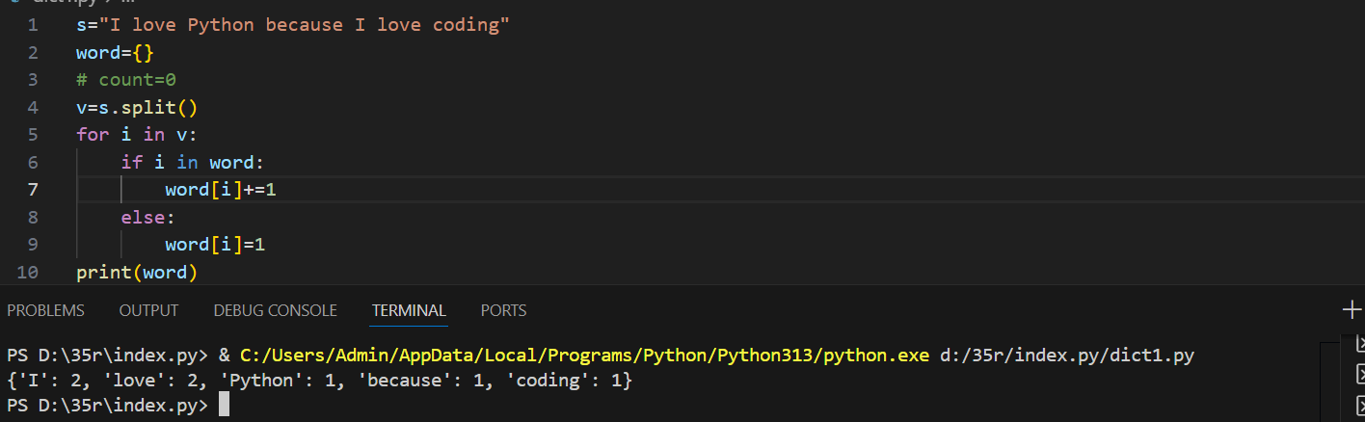

**🔄 2. Swap Keys and Values**

**Problem:**  
Write a program to swap keys and values in a dictionary.

**Example:**  
Input: {'a': 1, 'b': 2}  
Output: {1: 'a', 2: 'b'}

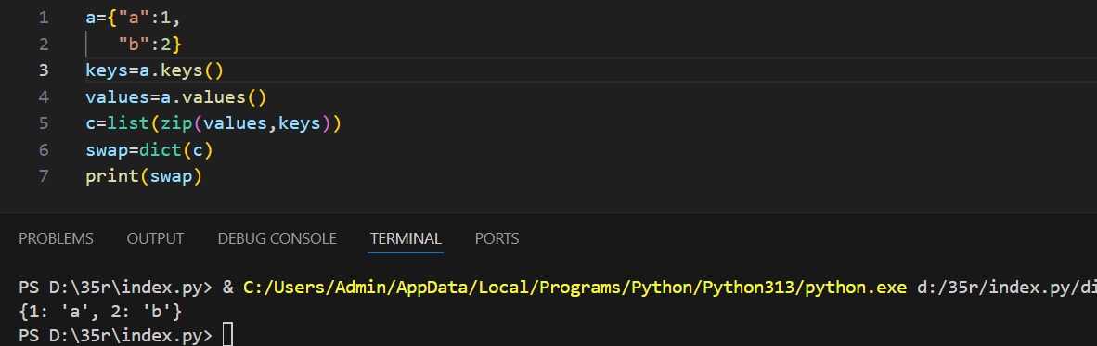

**🧮 3. Find the Key with the Maximum Value**

**Problem:**  
Given a dictionary, find the key with the highest value.

**Example:**  
Input: {'math': 90, 'science': 95, 'english': 88}  
Output: 'science'

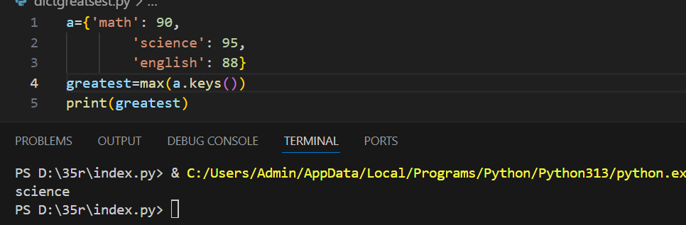

**🔢 4. Merge Two Dictionaries**

**Problem:**  
Write a function to merge two dictionaries. If keys are the same, add their values.

**Example:**

d1 = {'a': 10, 'b': 5}

d2 = {'a': 3, 'c': 8}

Output: {'a': 13, 'b': 5, 'c': 8}

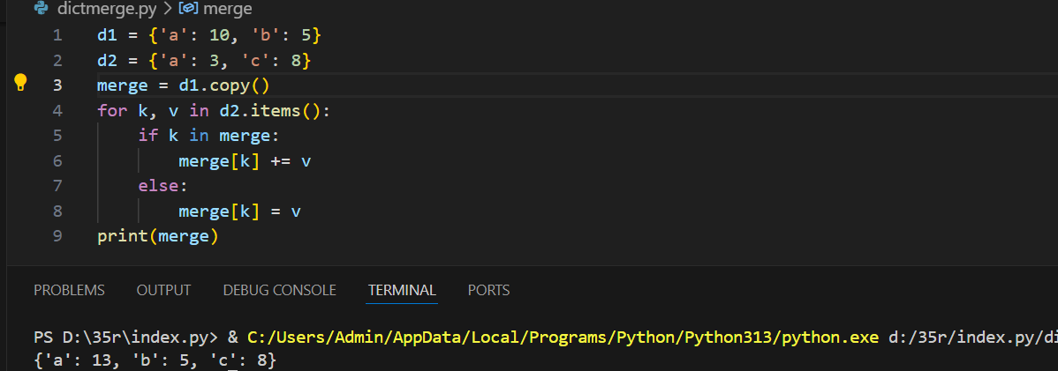

**✅ 5. Check if a Key Exists**

**Problem:**  
Ask the user for a key and check if it exists in a dictionary.

**Example:**  
Dict: {'x': 10, 'y': 20}  
User input: 'x'  
Output: Key exists.

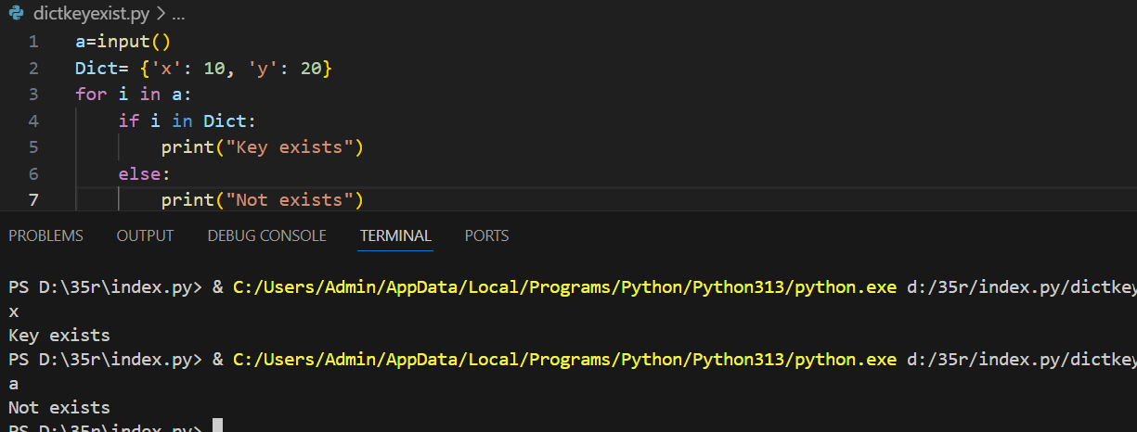

**🔄 6. Convert Two Lists into a Dictionary**

**Problem:**  
Convert two lists into a dictionary.

**Example:**

keys = ['id', 'name']

values = [1, 'Alice']

Output: {'id': 1, 'name': 'Alice'}

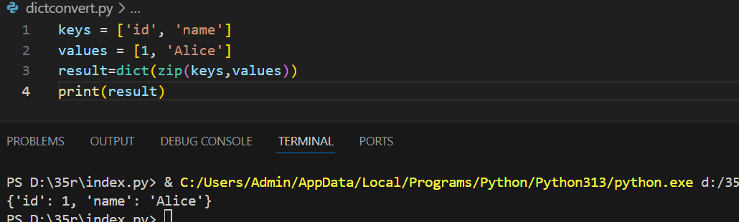

**🔁 7. Count Character Frequency in a String**

**Problem:**  
Count how many times each character appears in a string.

**Example:**  
Input: "hello"  
Output: {'h': 1, 'e': 1, 'l': 2, 'o': 1}

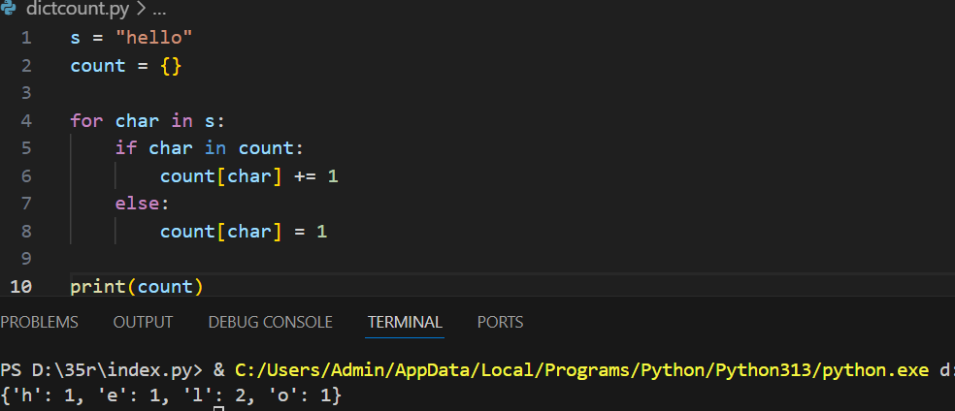

**🧪 8. Filter Dictionary by Value**

**Problem:**  
Filter out items from a dictionary where the value is less than 50.

**Example:**  
Input: {'a': 60, 'b': 45, 'c': 75}  
Output: {'a': 60, 'c': 75}

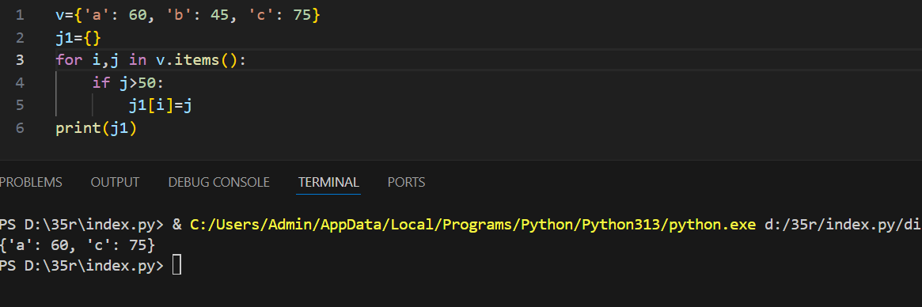

**🆔 9. Create a Dictionary from User Input**

**Problem:**  
Ask the user for 3 key-value pairs and store them in a dictionary.

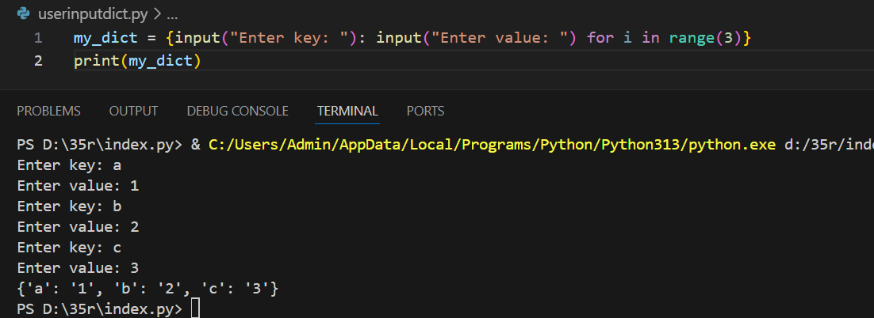

**🧵 10. Group Words by Their First Letter**

**Problem:**  
Group a list of words by their first letter into a dictionary.

**Example:**  
Input: ['apple', 'banana', 'apricot', 'blueberry']  
Output: {'a': ['apple', 'apricot'], 'b': ['banana', 'blueberry']}

